 | WEATHERIZATION WORK ORDER  Alder Residence — Portland, OR

Customer | Casey Alder
Address | 1234 SE Alder St, Portland, OR 97215
Phone | (503) 555-0136
Questions on site | Kyle — (503) 555-0117
Job # | 2026-0714
Install Dates | ___________________________
Crew Lead | ___________________________
⚠ SAFETY FLAGS: LEAD PAINT — 1962 home, lead-safe (RRP) practices on any paint disturbance
Scope of Work
Task | Details | Location
Attic air seal | Full ceiling plane: top plates, can lights, penetrations, flue dam; hold the hood + bath-fan duct spots Day 1 and close them after HVAC runs ducts Day 2 | Attic
Attic prep + insulation | Baffles at every eave bay, hatch dam + weatherstrip, 3 depth markers, then blow R-49 cellulose over 940 sf | Attic
Equipment Arriving
Item | Model | Qty
Outdoor unit | 24k cold-climate ductless ODU | 1
Wall heads | 12k (living) + 9k (bedroom) | 2
Bath fan | 110 CFM ENERGY STAR, humidistat | 1
Range hood | 300 CFM ducted | 1
Disconnect + whip | 60A non-fused | 1
Burch QA — Air Sealing
☐ All MEP penetrations sealed — attic to conditioned space (Q6)
☐ All MEP penetrations sealed — crawl to conditioned space (Q7)
☐ Gaps around chimneys/gas vents sealed with high-temp caulk/foam (Q8)
☐ Drywall sealed to top plates (Q11)
☐ Weatherstripping on all exterior door openings (Q10)
☐ Pre AND post blower door test conducted and recorded (Q13)
Burch QA — Attic Insulation
☐ Mold/water/pest damage mitigated before insulating (Q15)
☐ Attic ventilation at 1:300 net free area with bug screens on vents (Q16)
☐ Attic access lid insulated R-38+ and weatherstripped airtight (Q17)
☐ All ductwork sealed mastic/UL-181, insulated R-8, supported (Q18)
☐ Knee/skylight walls insulated R-21+ with attic-side air barrier (Q21)
☐ Insulation dams around chimneys/flues in heat-safe materials (Q22)
☐ Non-airtight recessed cans boxed over, seams sealed (Q23)
☐ Attic insulated to R-49, Grade 1 installation (Q25)
☐ Insulation baffles at all bird blocks (Q26)
Burch QA — ASHRAE 62.2 Ventilation
☐ Whole-house ventilation meets the ASHRAE 62.2 calculation (Q44)
☐ Kill switch acceptably located for continuous fans (Q46)
☐ Controls labeled appropriately (Q48)
☐ Operation/maintenance instructions provided to occupant (Q49)
☐ Whole-house exhaust fan rated 1 sone or quieter (Q50)
Burch QA — Safety & Critical Repairs
☐ Radon test at end of project — result 4 pCi/L or lower — when air sealing is in scope (Q133)
☐ Smoke and CO monitors installed to code (Q136)
☐ Asbestos handled per Oregon DEQ when present (Q131-132)
☐ Lead paint: EPA RRP compliance on pre-1978 homes when paint is disturbed (Q137)
Permits
☐ Permits closed out for EACH inspected installed measure (Q162)
☐ Permit finals scheduled BEFORE requesting the program QA inspection
☐ Inspection cards / permit numbers photographed for the job file
Notes for Crew
• Homeowner is on video calls in the back office — knock at the front door, headphones mean go around
• Keep the driveway clear of material staging after 4pm (street sweeping Tuesday)
• Cat is friendly and sneaky — check for her before closing the attic hatch
Reference Photos
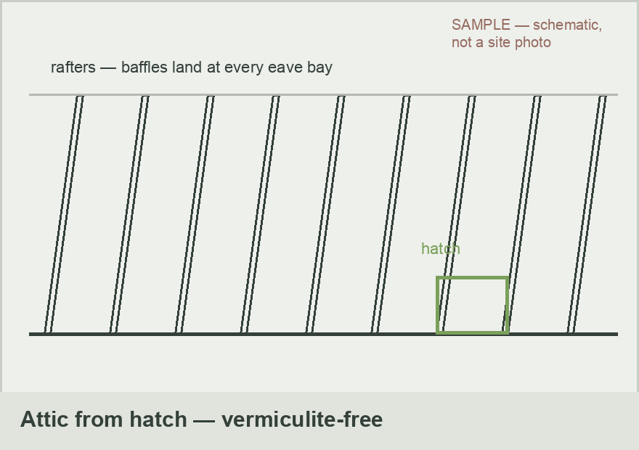 | 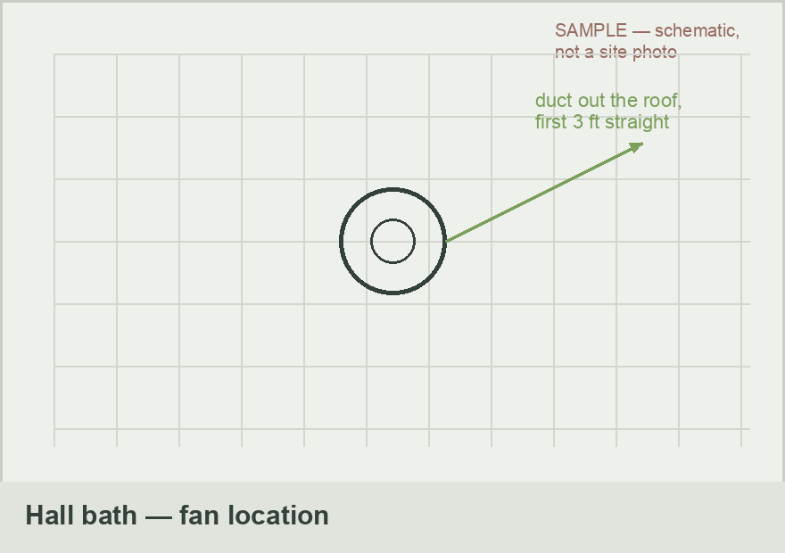
Attic from hatch — vacuum out, air-seal, baffles at every eave bay | Hall bath fan location — duct out the roof, first 3 ft straight
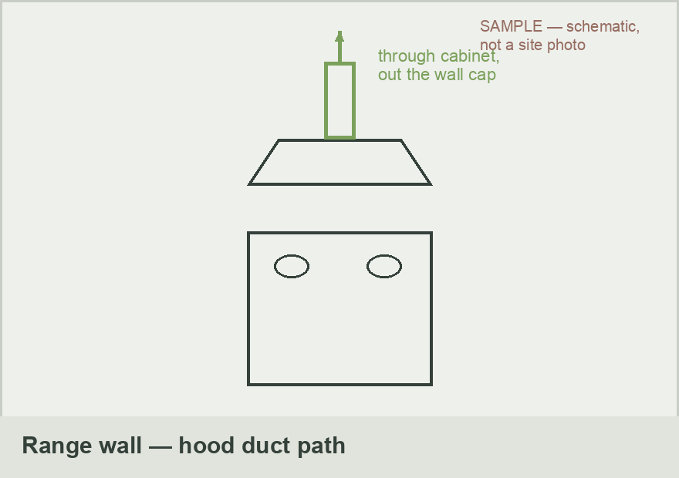
Range wall — hood ducts through the upper cabinet, out the wall cap

Resilient Retrofits · CCB# 245539 · Prepared by: Kyle Kanooth

